QUESTION – 1

Since π and $e$ are irrational numbers which means that they cannot be represented as a fraction of two numbers. Since floating point system is defined as

$$fl\left(x\right)=±\left(\frac{d_{0}}{ß^{0}}+\frac{d_{1}}{ß^{1}}+…+\frac{d_{t-1}}{ß^{t-1}}\right)×ß^{e}$$

Which can be sum into a single fraction that produces the same result. In the case of π and $e$ this cannot be done since they cannot be represented as a fraction. Which means there is no floating point system that have an exact representation of π and $e$.

QUESTION – 2

For a floating system that has base 7 (β = 7) and precision 2 (*t = 2*), $\frac{8}{7}$ does have an exact representation.

ẞ = 7

*t* = 2

$${\left(1.1x7^{0}\right)}_{7} = \left(\frac{1}{7^{0}} + \frac{1}{7^{1}}\right) ×7^{0}=\frac{8}{7}$$

QUESTION – 3

I have a Casio fx-82ES PLUS which is a scientific calculator. In order to find rounding unit of this calculator, we must find a number such that it will be rounded up no matter where it’s cut. Best solution for this is a number that has a repeating decimal. Such as;

$$\frac{20}{3} = 6,\overline{6 }$$

$6,\overline{6}$ will be rounded up wherever it is cut. When I enter $\frac{20}{3}$ into my calculator I get the result;

$$\frac{20}{3} = 6,666666667$$

Which indicates rounding unit of my calculator is ${1 × 10}^{\left(-9\right)} ×{10}^{e}$. (e = exponent)

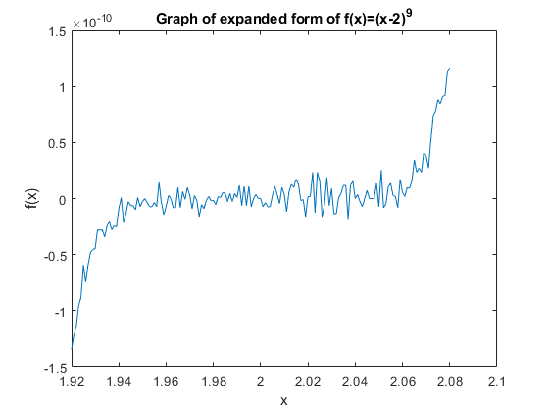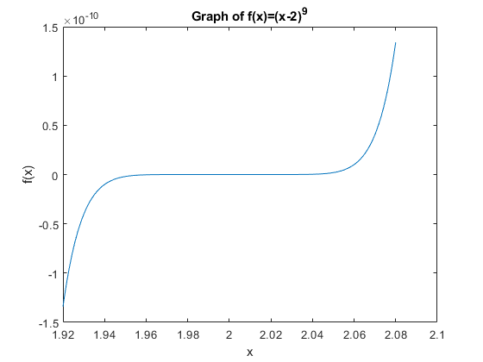QUESTION – 4

Figure 2

Figure 1

Graphs in Figure 1 and Figure 2 are created with the MATLAB code below. As we can see while the graph in Figure 2 is smooth, the graph in Figure 1 is wobbly. Since the expanded version of the function requires taking exponents of x from 9 to 1. Which results in some floating points that need to be rounded. Since every term is rounded, roundoff error becomes big and changes for every x, which creates this wobbliness in Figure 1. In Figure 2 however, rounding is done once for every x which means less roundoff error. That makes graph smoother.

**function** hw1q4**()**

x **=** 1.92**:**0.001**:**2.08**;**

figure**();**

plot**(**x**,**f1**(**x**));**

title**(**'Graph of expanded form of f(x)=(x-2)^9'**);**

xlabel**(**'x'**);**

ylabel**(**'f(x)'**);**

figure**();**

plot**(**x**,**f2**(**x**));**

title**(**'Graph of f(x)=(x-2)^9'**);**

xlabel**(**'x'**);**

ylabel**(**'f(x)'**);**

**function** y **=** f1**(**x**)**

% This function returns %y = x^9 - 18*x^8 + 144*x^7 - 627*x^6 + 2016*x^5 - 4032*x^4 + 5376*x^3 - 4608x^2 + 2304*x - 512

y **=** x**.^**9 **-** 18**\***x**.^**8 **+** 144**\***x**.^**7 **-** 672**\***x**.^**6 **+** 2016**\***x**.^**5 ...

**-** 4032**\***x**.^**4 **+** 5376**\***x**.^**3 **-** 4608**\***x**.^**2 **+** 2304**\***x **-** 512**;**

**end**

**function** y **=** f2**(**x**)**%This function returns

% y = (x-2)^9

y **=** **(**x**-**2**).^**9**;**

**end**

hw1q4.m MATLAB Code